I Installed One Skill. Now Claude Code Finds Every Other Skill For Me.
One prompt. It searches the entire skill registry, checks what you already have, and tells you whether you even need to install anything.

I spent twenty minutes last week looking for the right way to pull qualified leads from Apollo inside a Claude Code session. I knew skills existed. I knew the marketplace existed. I had no idea which one to install, whether it overlapped with something I already had connected, or whether it was even maintained.
That’s the actual problem with Claude Code’s skill ecosystem right now. Not that skills don’t exist. That you can’t find the right one without already knowing what it’s called.
find-skills fixes that.

Install the one skill that finds all the others
npx skills add vercel-labs/skills@find-skills
That’s it. Once it’s in your session, you describe what you’re trying to do in plain English — not the tool name, not the package, just the outcome — and it searches the registry and comes back with ranked options.
I typed:
“find me a skill that helps me find correct leads from Apollo”
Here’s what came back:
Press enter or click to view image in full size
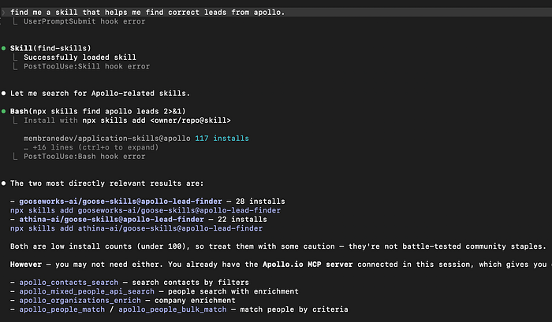
Claude Code query for finding skill
Two relevant results: gooseworks-ai/goose-skills@apollo-lead-finder (28 installs) and athina-ai/goose-skills@apollo-lead-finder (22 installs). It flagged both as low-install-count — not battle-tested, use with caution.
Then it told me I probably didn’t need either.
I already had the Apollo.io MCP server connected, which gives me apollo_contacts_search, apollo_mixed_people_api_search, apollo_organizations_enrich, and apollo_people_match directly. No extra install required.
That second part is what I hadn’t expected. It didn’t just answer what I asked. It checked what I already had and told me I was overthinking it.

The purpose of install count
The skill registry is open. Anyone can publish. That means quality varies and the only honest signal is how many other people have installed something and kept it.
28 installs is low. membranedev/application-skills@apollo has 117. That gap matters — 117 means someone other than the author found it useful enough to actually use. 28 means you're closer to being a beta tester than a user.
find-skills surfaces this information rather than hiding it behind a clean UI. That's the right call.

What I actually ran once I knew what I had
Since Apollo MCP was already live in my session, I used apollo_mixed_people_api_search directly. The use case: founders and CTOs at Series A SaaS companies in the US, 11–200 employees.
{
"person_titles": ["Founder", "CTO", "VP Engineering"],
"organization_num_employees_ranges": ["11,50", "51,200"],
"organization_latest_funding_stage_cd": ["series_a"],
"person_locations": ["United States"]
}
The point isn’t the query. The point is I was about to install a third-party skill to do something I already had native access to. find-skills caught that before I wasted time on it.

How to actually use it
Describe the outcome, not the tool:
- Not: “find me an apollo skill”
- Yes: “I need to search for decision-makers at funded startups by industry and title”
The more specific your intent, the more useful the results. Vague prompts get vague matches.
If it surfaces something with under 50 installs, check the repo before installing. Look at the last commit date. If it hasn’t been touched in six months and has no issues or stars, that’s your answer.
The skill marketplace is genuinely useful but it has a discovery problem. Most people using Claude Code don’t know half of what’s available, and the ones who do know usually found it by accident.
find-skills is a one-time install that makes the whole ecosystem searchable. Worth having in every session.

